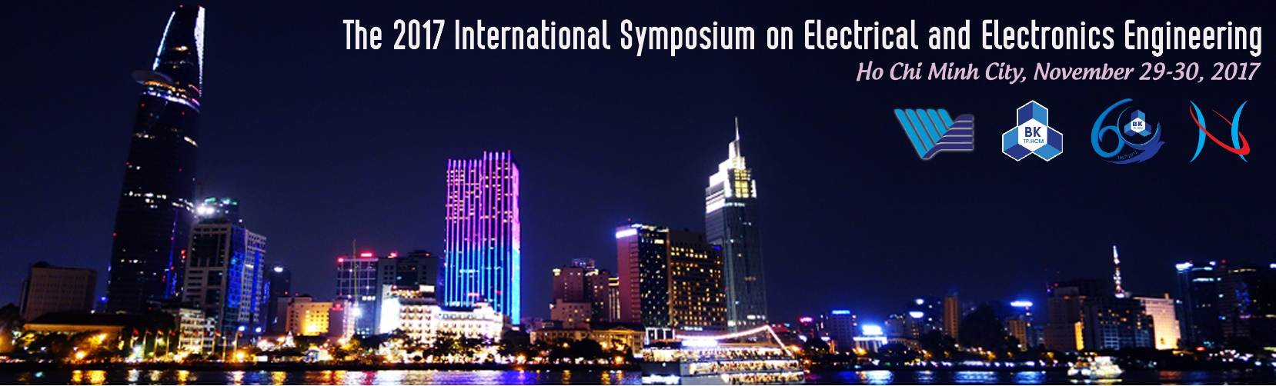

ISEE 2017 REGISTRATION FORM
(Note: Fill all the information in capital format only)

PLEASE KINDLY FILL IN A SEPARATE REGISTRATION FORM FOR EACH CONFERENCE PARTICIPANT

Title (*): 1.Dr. 2. Mr. 3. Ms. 4. Prof. |  | Name
Affiliation*
City, Zip, Country
Mobile |  | Email (*)
ACCEPTED PAPER INFORMATION | Paper ID:  Title of the paper:  Authors:
Type of Participation* | Presenter.  Attendee.
Registration Package | Oversea attendees (150USD)  Local attendees (1.000.000VND)  FEEE members (Free) | Additional Proceedings (20USD or 400.000VND)  Additional Gala dinner Coupon (500.000VND).

Participant’s Signature (*): ..........................................
Note:
The conference registration for oversea attendees include admission to all conference sessions, coffee break refreshments, Banquet, and a copy of the Conference Proceedings.
The conference registration for local attendees and FEEE members include admission to all conference sessions, coffee break refreshments and a copy of the Conference Proceedings.
REGISTRATION FORM SUBMISSION: A completed registration form needs to be sent as an email attachment to Conference Secretariat, Dr. Dung Trinh at dung.trinh@hcmut.edu.vn.

